22CS015



AI/ML

TELCO CUSTOMER CHURN

**Submitted By: Supervised By:**

TEAM MEMBER 1-NISHTHA (2210991992) Mr. ANOOP DOBHAL

TEAM MEMBER 2- PRACHI ANEJA (2210992053)

TEAM MEMBER 3- PRAGTI GUPTA (2210992056)

TEAM MEMBER 4- PRIYA GUPTA (2210992096)

**Department of Computer Science and Engineering**

**Chitkara University Institute of Engineering & Technology,**

**Chitkara University, Punjab**

# **INSIGHTS: CUSTOMER CHURN**

## ABOUT THE DATASET:

#### **Key Columns:**

customerID: Unique identifier for each customer.

gender: Gender of the customer.

SeniorCitizen: Indicates if the customer is a senior citizen (0 for No, 1 for Yes).

Partner: Indicates if the customer has a partner (Yes or No).

Dependents: Indicates if the customer has dependents (Yes or No).

tenure: Number of months the customer has been with the company.

PhoneService: Indicates if the customer has a phone service (Yes, No).

MultipleLines: Indicates if the customer has multiple lines (Yes, No, No phone service).

InternetService: Type of internet service subscribed by the customer (DSL, Fiber optic, No).

OnlineSecurity: Indicates if the customer has online security (Yes, No, No internet service).

DeviceProtection: Indicates if the customer has device protection (Yes, No, No internet service).

TechSupport: Indicates if the customer has tech support (Yes, No, No internet service).

StreamingTV: Indicates if the customer has streaming TV service (Yes, No, No internet service).

StreamingMovies: Indicates if the customer has streaming movies service (Yes, No, No internet service).

Contract: Type of contract the customer has (Month-to-month, One year, Two year).

PaperlessBilling: Indicates if the customer has opted for paperless billing (Yes or No).

PaymentMethod: Payment method used by the customer.

MonthlyCharges: Monthly charges for the services.

TotalCharges: Total charges billed to the customer.

Churn: Target variable indicating if the customer has churned (Yes or No).

#### **OBJECTIVE:**

The primary objective of this dataset seems to be predicting customer churn based on the provided features. Churn prediction is crucial for businesses, especially in industries like telecom, where retaining customers is essential for long-term success.

DATA OVERVIEW:

NUMERICAL DATA:

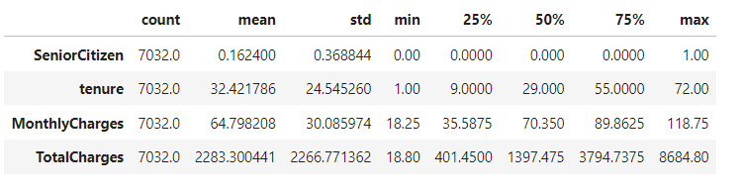

CATEGORICAL DATA:

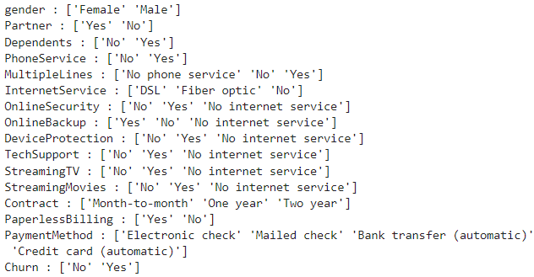

DISTRIBUTION:

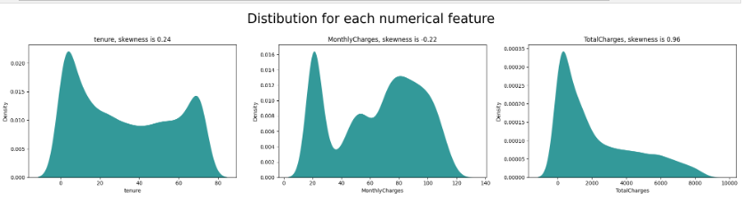

* The first observation with a skewness value of 0.24 suggests a slight right-skewed distribution, indicating that there are slightly more data points on the lower end of the range.
* The second observation with a skewness value of -0.22 suggests a slight left-skewed distribution, indicating that there are slightly more data points on the higher end of the range.
* The third observation with a skewness value of 0.96 suggests a strongly right-skewed distribution, indicating that there are significantly more data points on the lower end of the range, with a much longer right tail.

The skewness value is relatively small, suggesting that the skewness is not very pronounced. However, we will be further dealing with the skewness of Totalcharges in the notebook.

CHURN RATE:

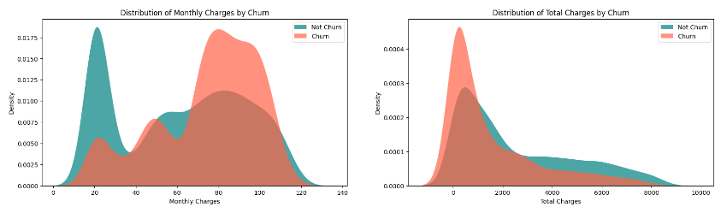

If the Monthly charges are increased per month then Customer churning gets increased as compared to Total charges.

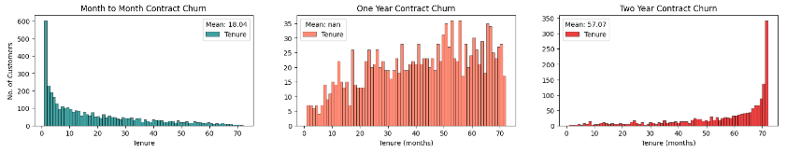

* a lot of Customers churned after just a month
* a lot of Customers are with the provider for 72 weeks
* the longer the contract, the longer customer stays with the provider (higher mean score)

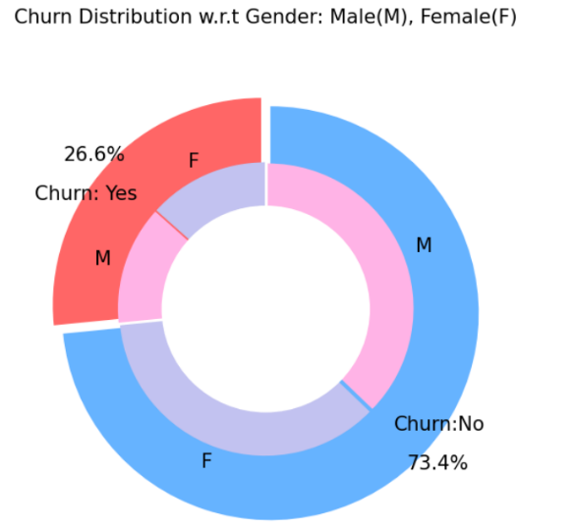

 There is negligible difference in customer percentage/ count who chnaged the service provider. Both genders behaved in similar fashion when it comes to migrating to another service provider/firm.

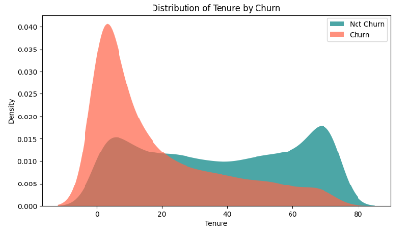

The longer the customer has been with the provider the more likely he will not churn.

SKEWNESS:

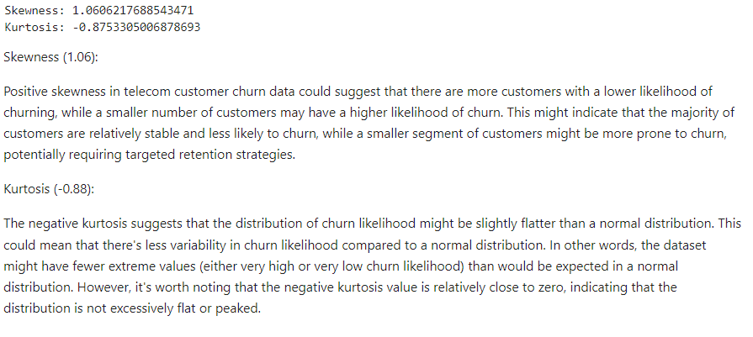

FORMING THE CORRELATION MATRIX AFTER USING LABEL ENCODING:

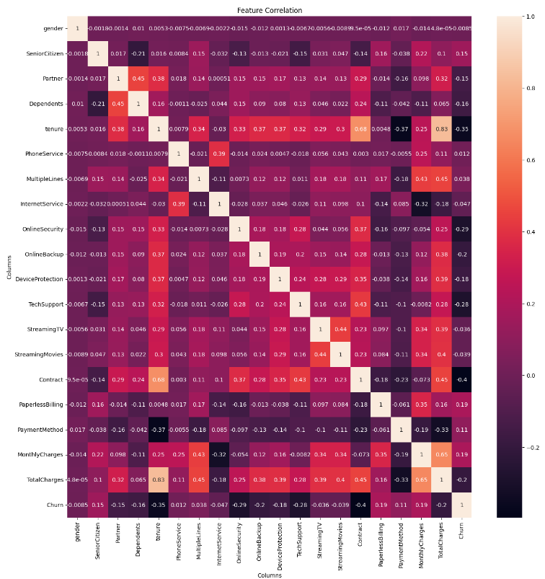

USING SMOTE FOR HANDLING IMBALANCED DATA:

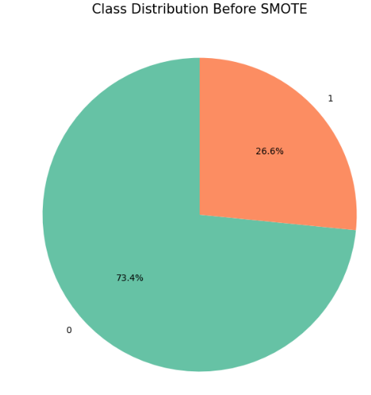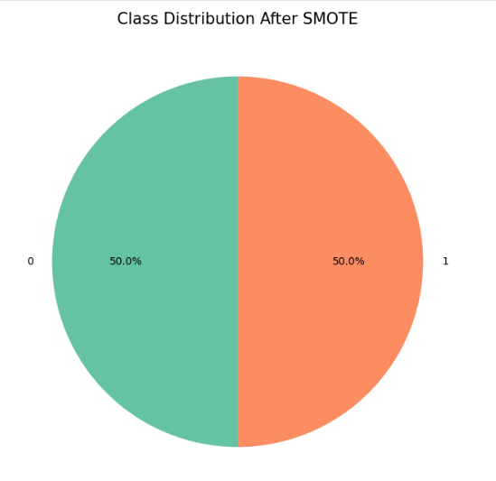

**Model Insights:-**

**Accuracy of all applied Models WITH/WITHOUT SMOTE:**

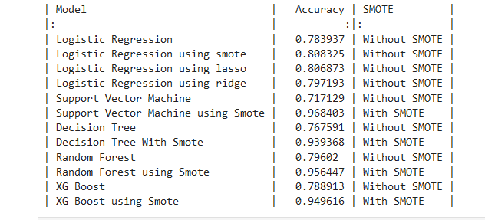

**Model Scores:**

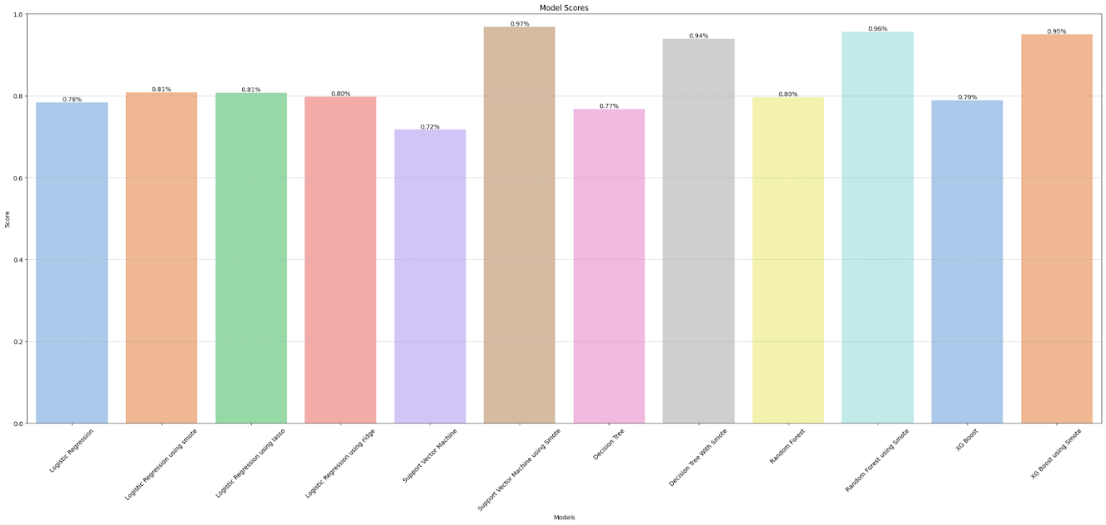

**ROC Curves of Models:**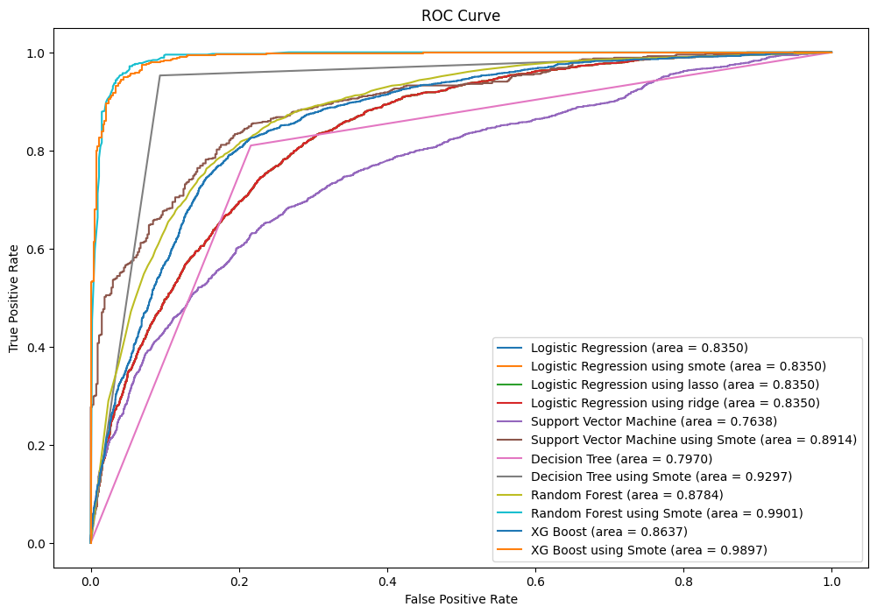

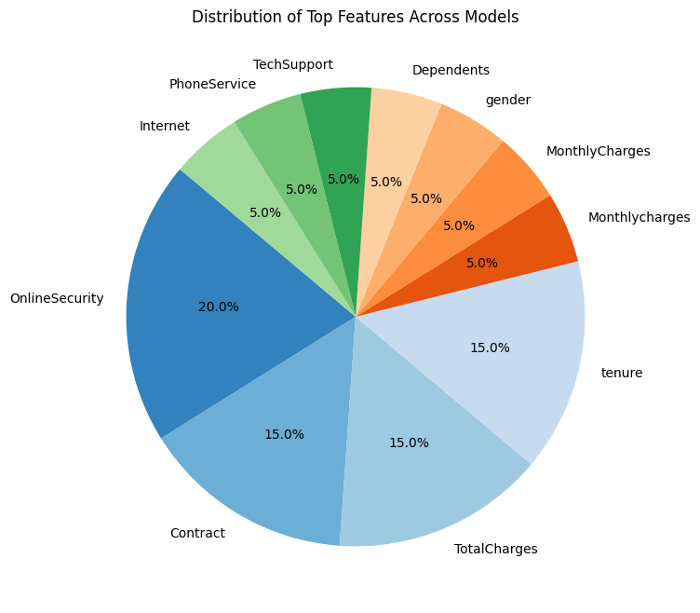

**FLASK DASHBOARD:-**

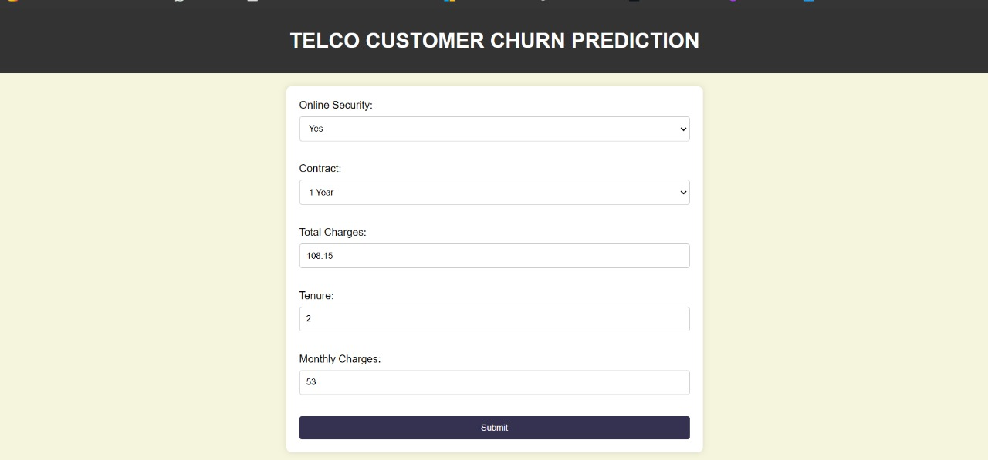

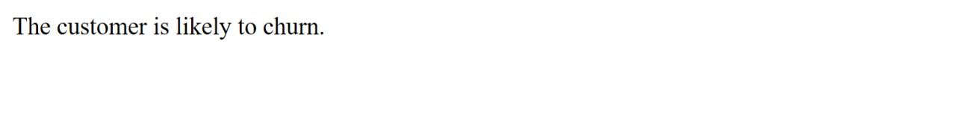

**CODE SNIPPETS:-**

